**Sales Comparison Dashboard Report**

**Objective:**

To develop an interactive Tableau dashboard that visually compares sales metrics between two selected regions—**Primary Region** and **Secondary Region**—helping upper management analyze performance and identify areas for improvement.

**Dataset Used:**

**Sample Superstore (Dataset)**

This dataset includes detailed information on sales, orders, customer demographics, and product information across different regions.

**Project Workflow and Key Steps:**

**1. Data Preparation and Structuring:**

* **Connected the Sample Superstore dataset** in Tableau.
* **Created a folder** using "Group by Folder" in the Data pane to organize fields:
  + Moved Customer Name and Order ID into this folder to streamline access and improve data management.

**2. Hierarchy Creation:**

* Created a **Location hierarchy** consisting of:
  + Country, State, and City for drill-down geographic analysis.

**3. Parameter Creation:**

* Created two parameters:
  + Primary Region: Dropdown with all available regions (e.g., East, West, Central, South).
  + Secondary Region: Same options as above.

**4. Calculated Fields:**

* **Region Filters:**
  + Created a calculated field named Is Primary Region:

**[Primary Region] = [Region]**

* + Created a calculated field named Is Secondary Region:

**[ [Secondary Region] [Region]**

* **First Order Date:**
  + Calculated the first order date per region:

**MIN([Order Date])**

* **Total Sales, Average Sales per Order, Number of Orders, Number of Customers, Number of Products:**
  + Created KPIs using LOD expressions and filters for each metric for both primary and secondary regions

**Dashboard Layout:**

The dashboard is designed with a **side-by-side comparison layout** for intuitive understanding:

We have total 11 sheets combined and made overall dashboard:

1. **Primary Measures:**

1. **Primary Map:**

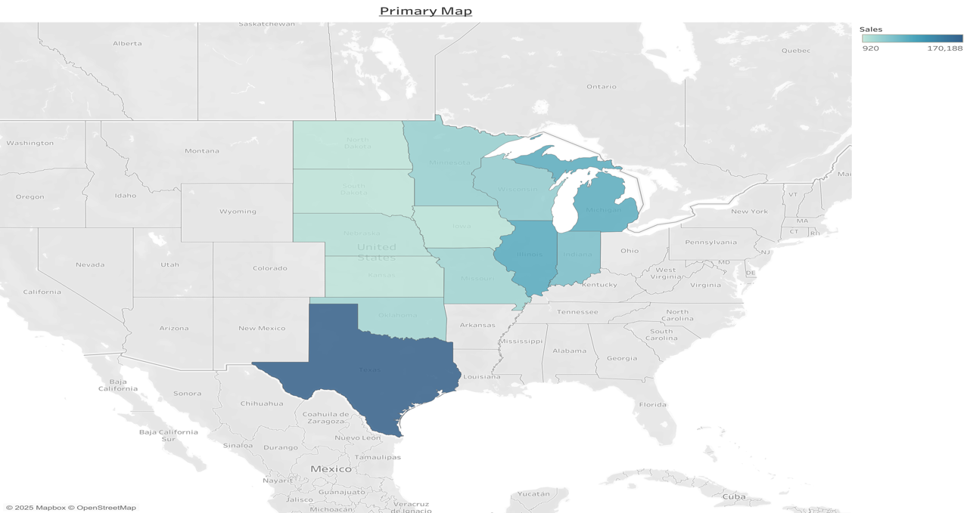

1. **Primary Sales Calculation:**

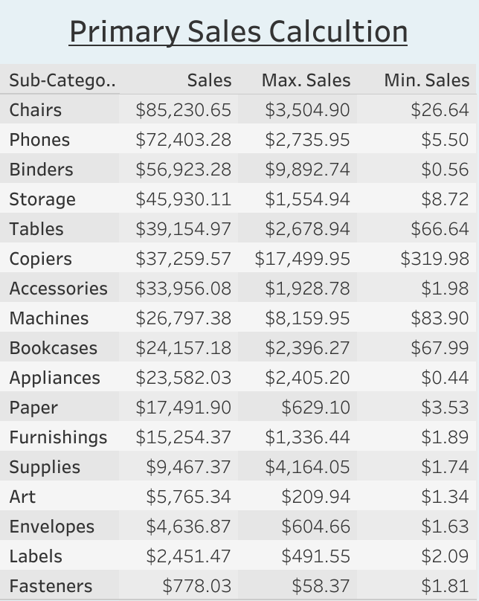

1. **Primary Yearly Sales:**

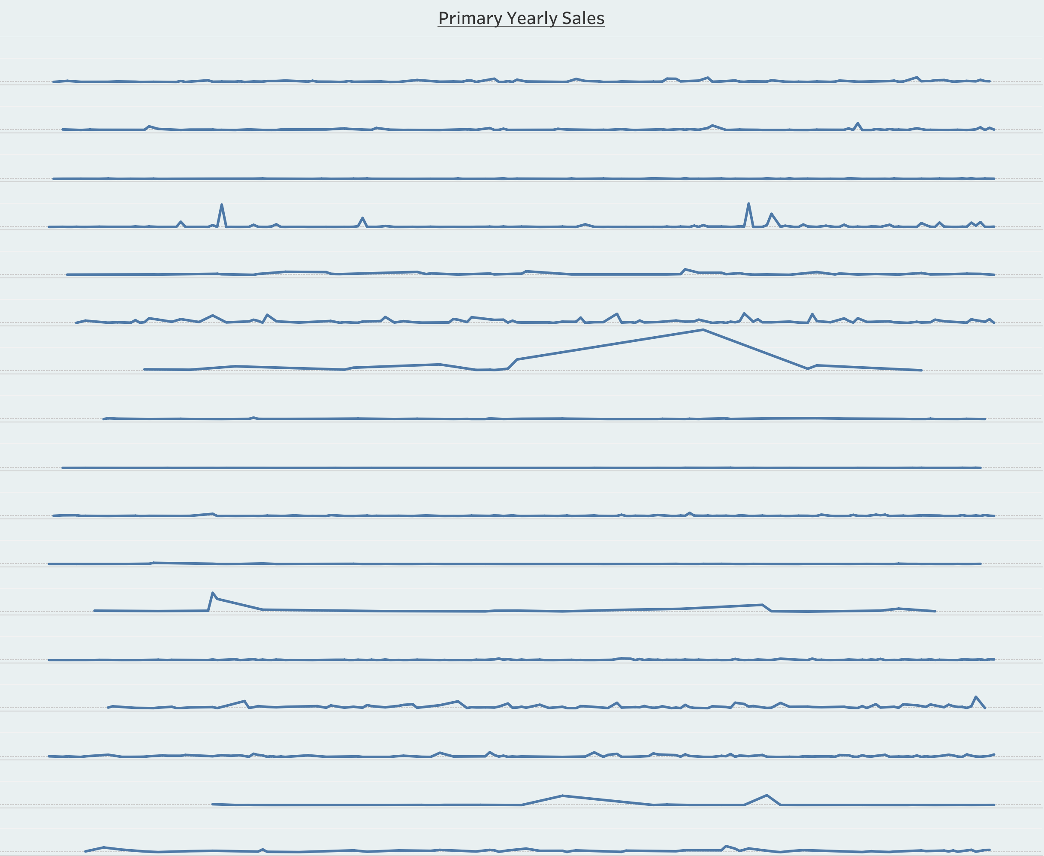

1. **Primary Sales:**

1. Secondary Measures:

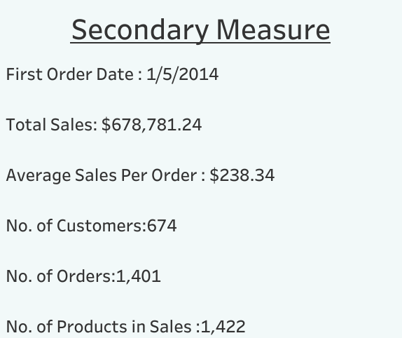

1. Secondary Map:

1. Secondary Sales Calculations:

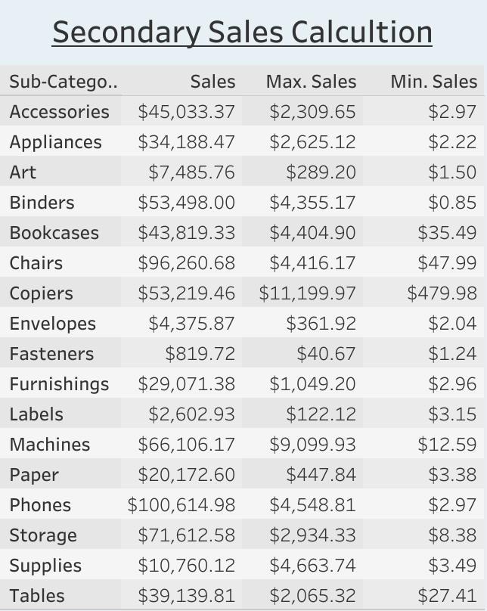

1. Secondary Yearly Sales:

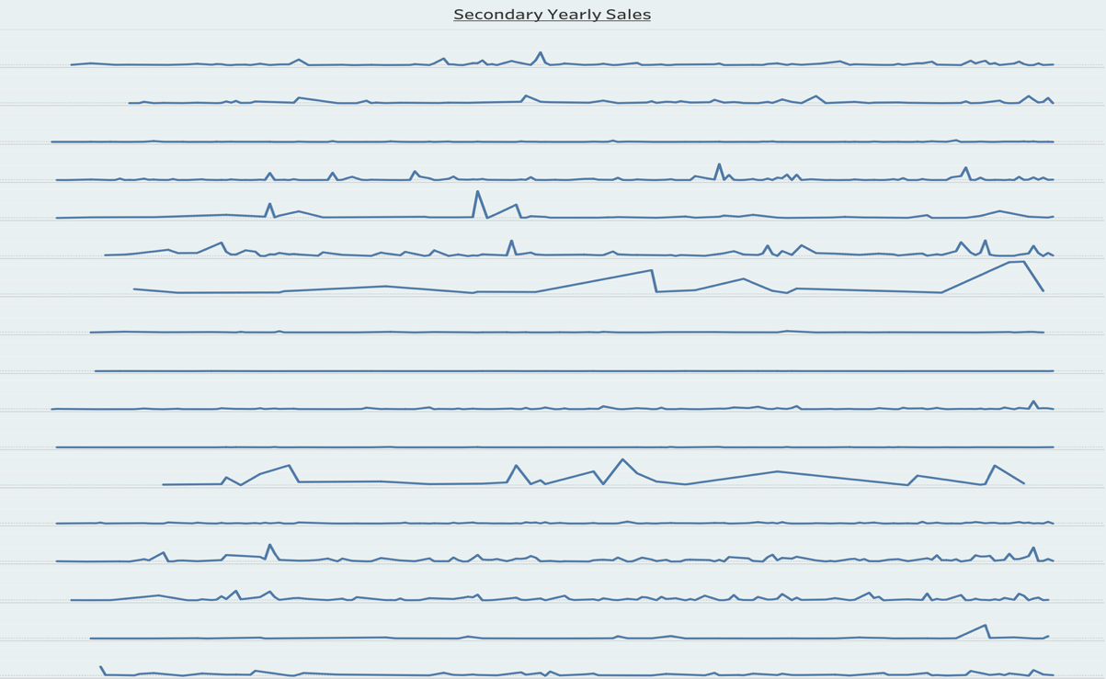

1. Secondary Sales:

1. Dashboard:

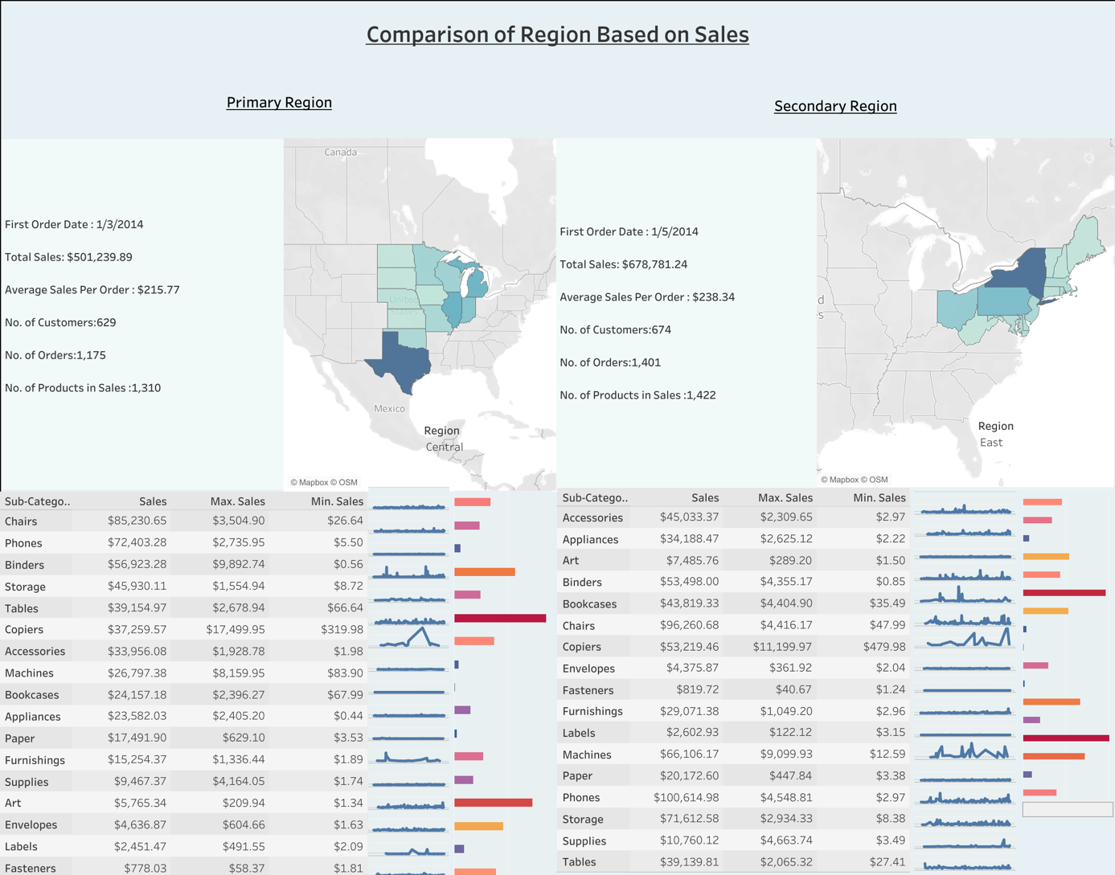

1. **Interactive Region Selectors** (using parameters)
2. **Consistent Color Coding** for clarity and distinction between the two regions
3. **Tooltip Enhancements** for deeper insights on hover